SOCIAL STORY

VICTORIAN DISABILITY SPORT
AND RECREATION FESTIVAL
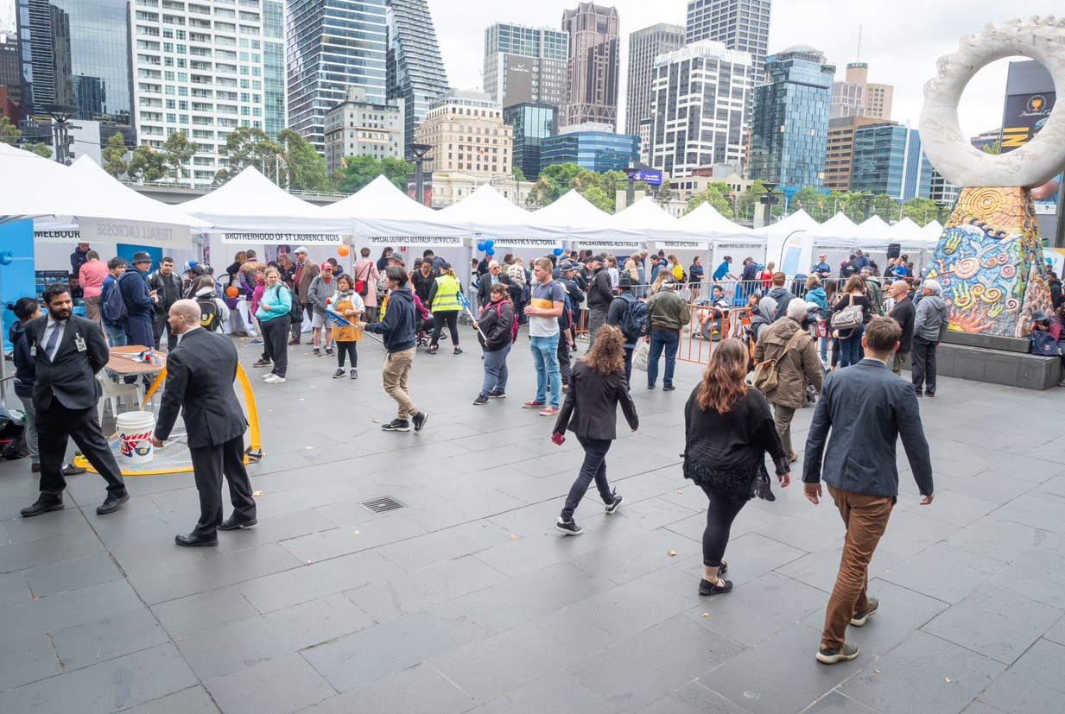

The Disability Sport and Recreation Festival will be held
outside on the Yarra Promenade near Crown Casino.
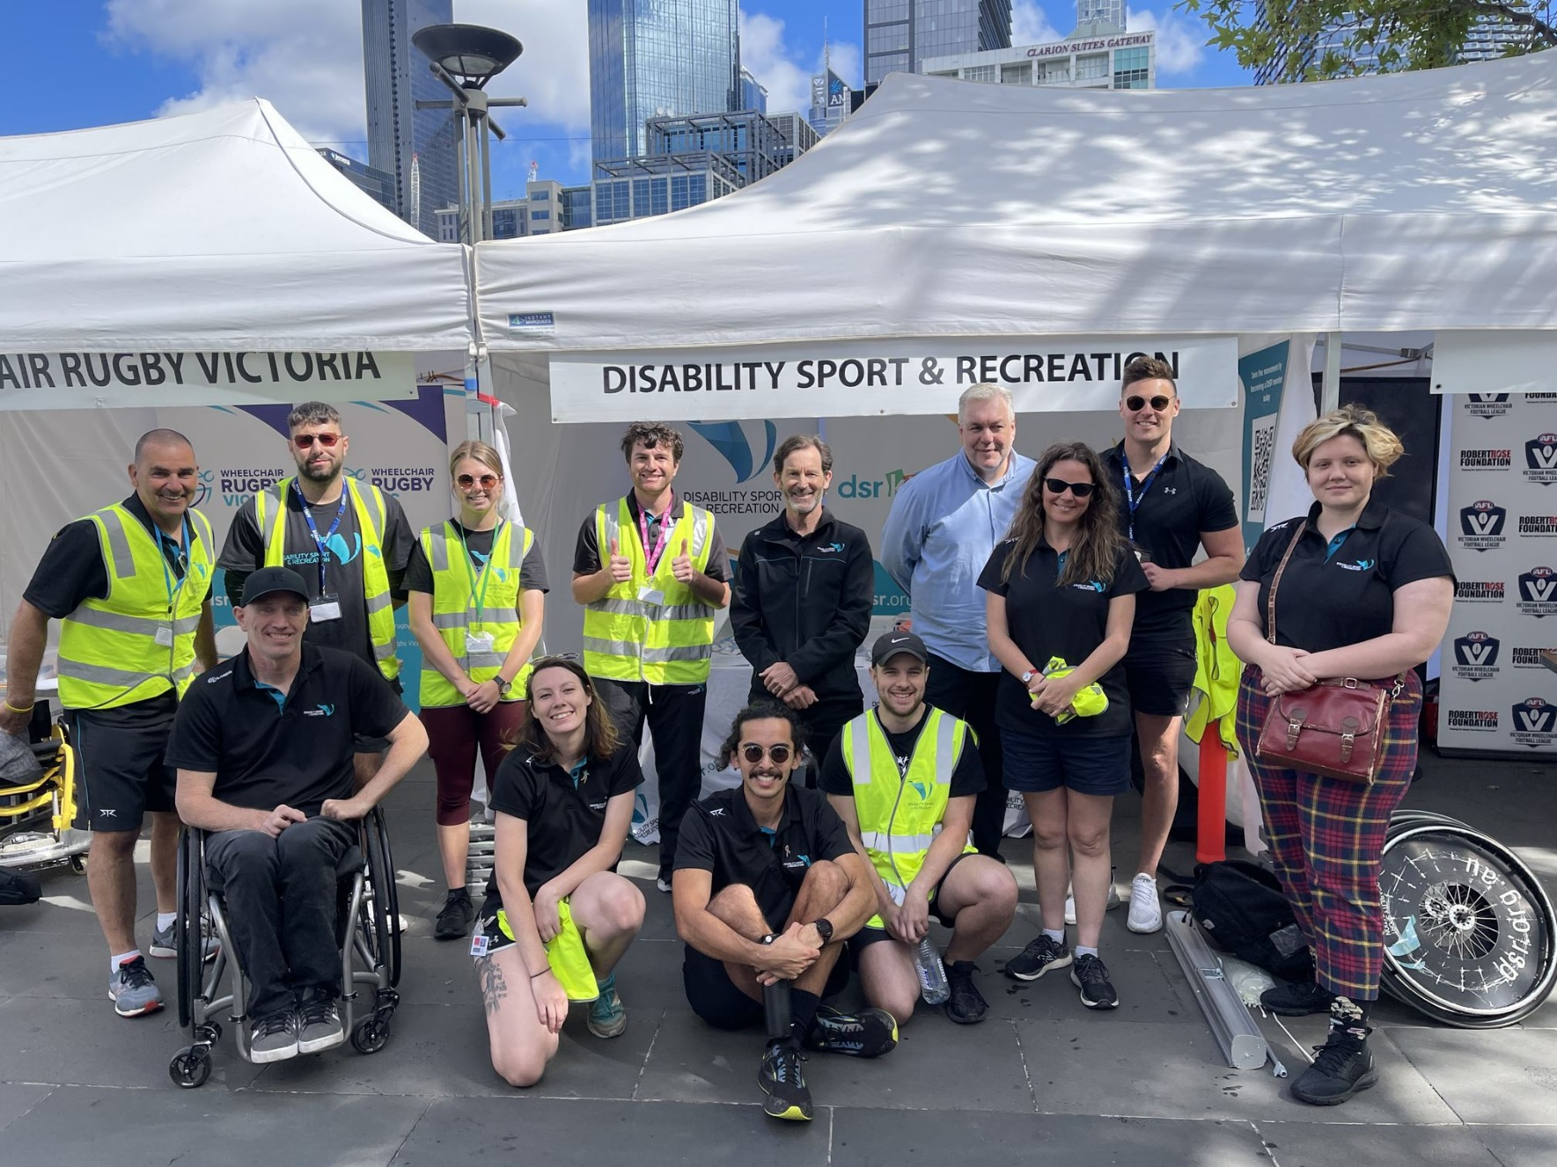

When you arrive, our friendly staff and volunteers in the
yellow vests will help show you where to go.
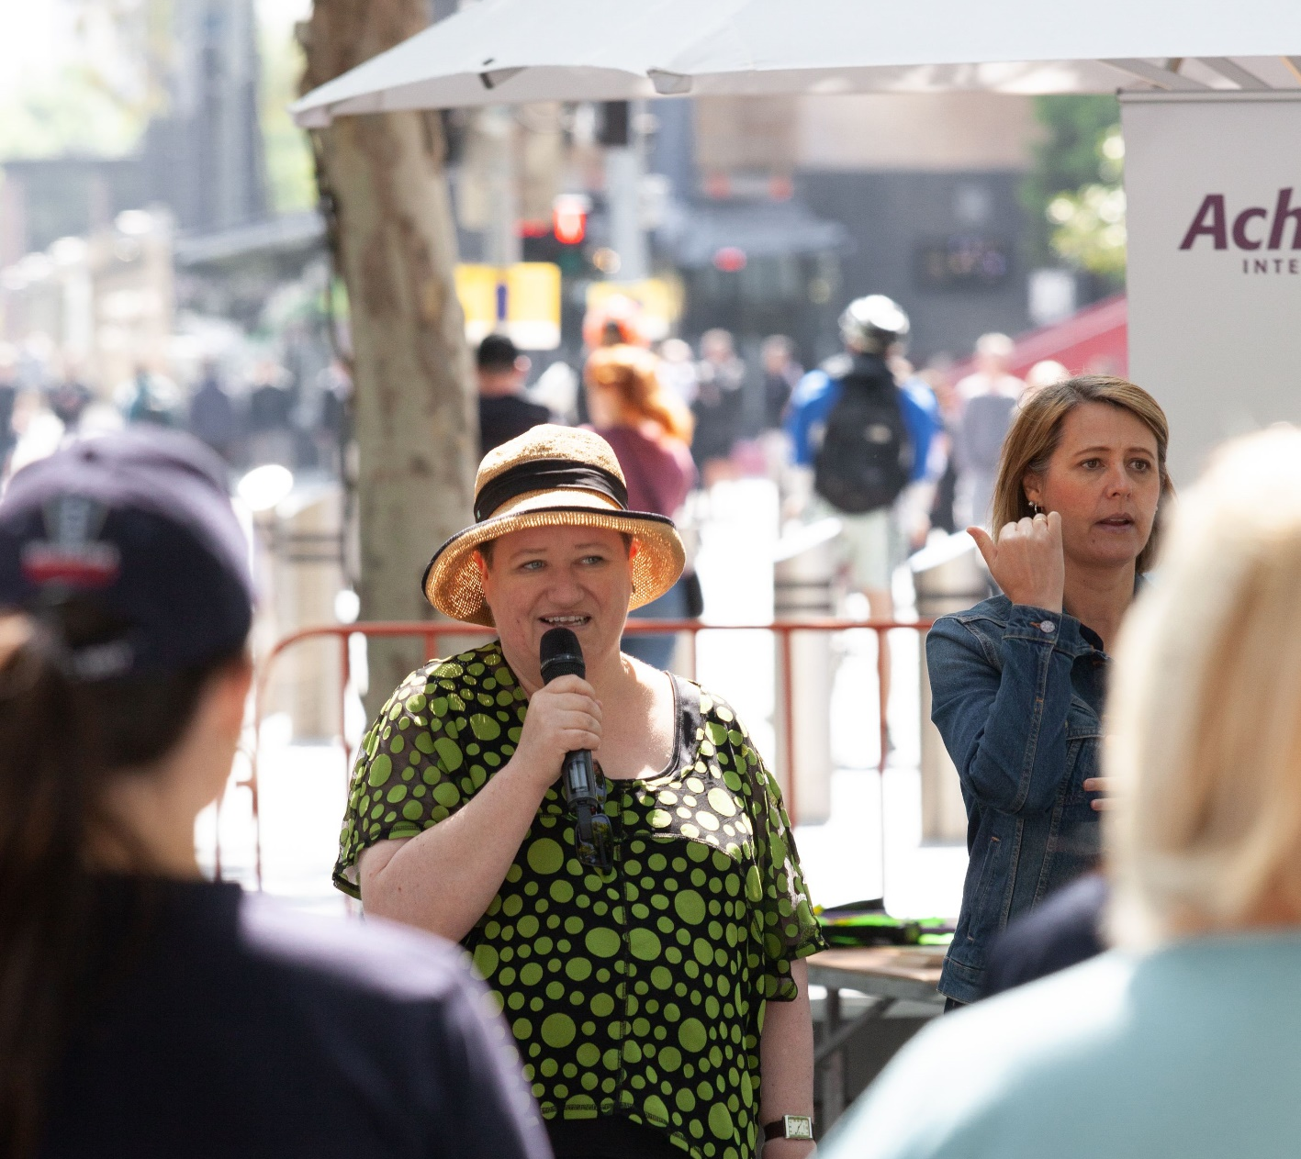

There will be welcome speeches from City of Melbourne and Disability
Sport & Recreation representatives, with an Auslan interpreter.
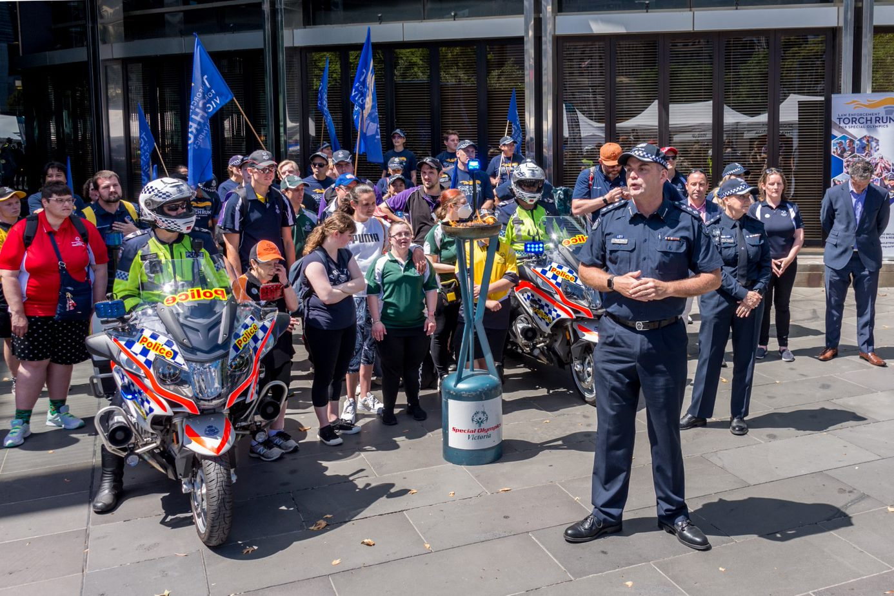

You can watch the ‘Flame of Hope’ torch parade involving Special
Olympics athletes and Victoria Police members.
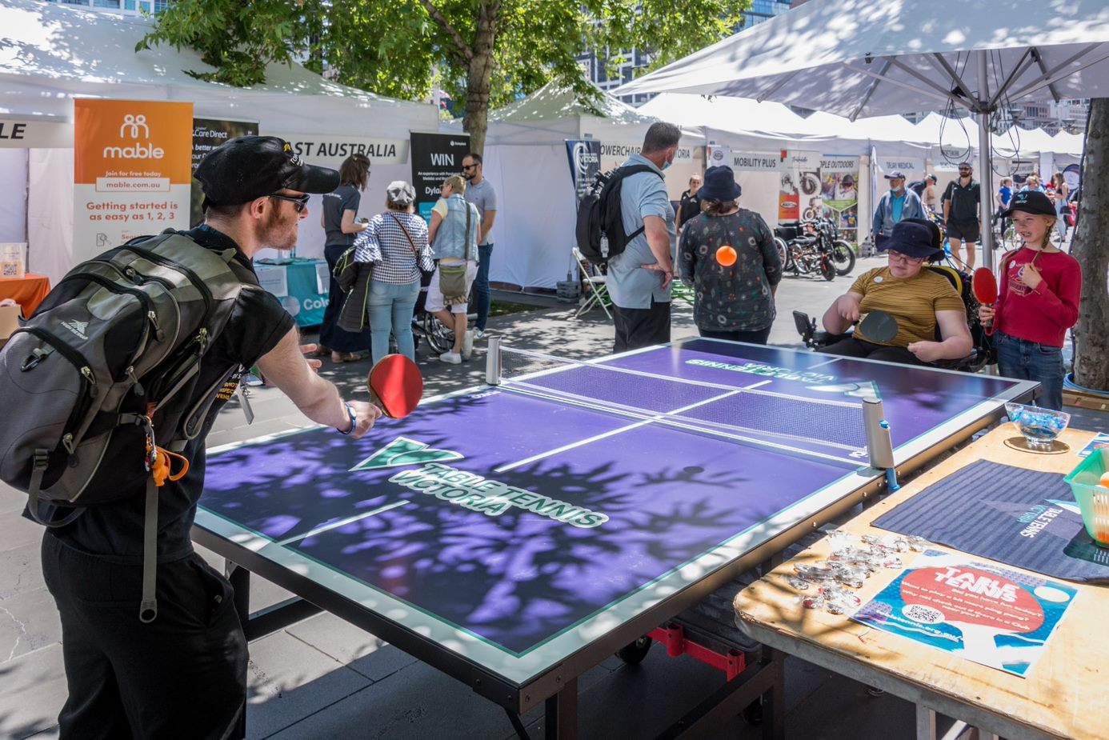

There will be over 20 sports providers at the Festival, with
activity zones for you to try the fun activities on offer.
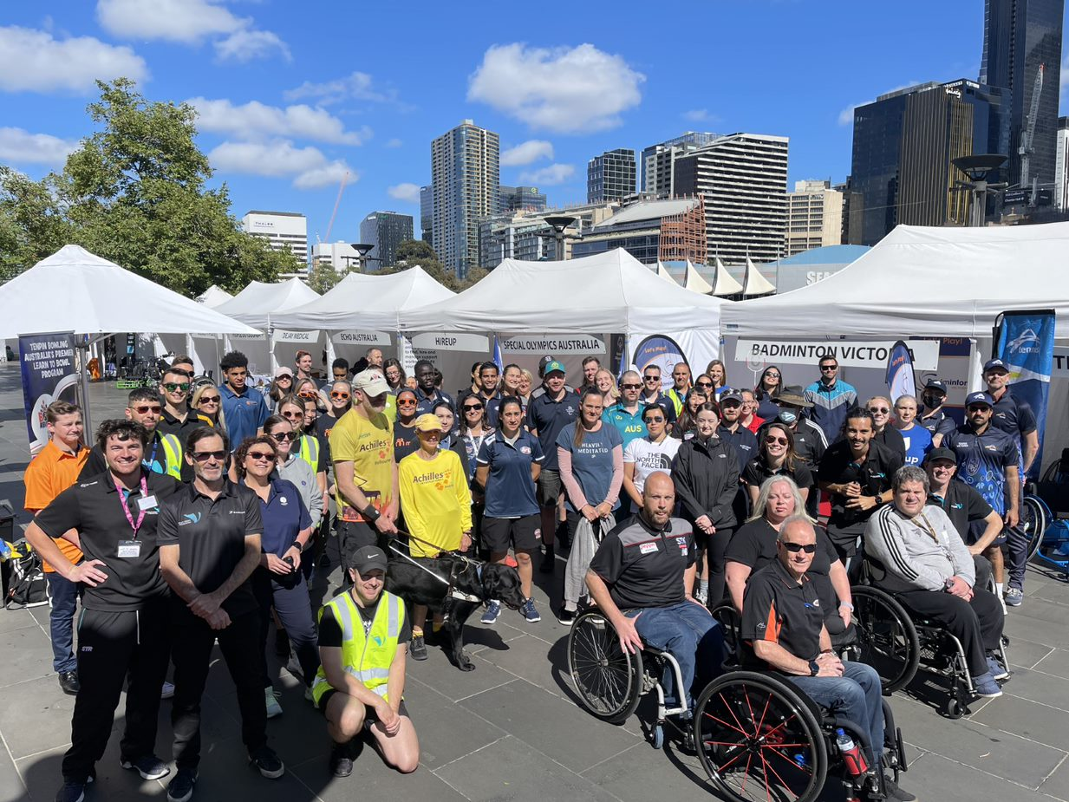

You can visit the friendly people at the white marquee tents
to ask questions and find out information about their services.
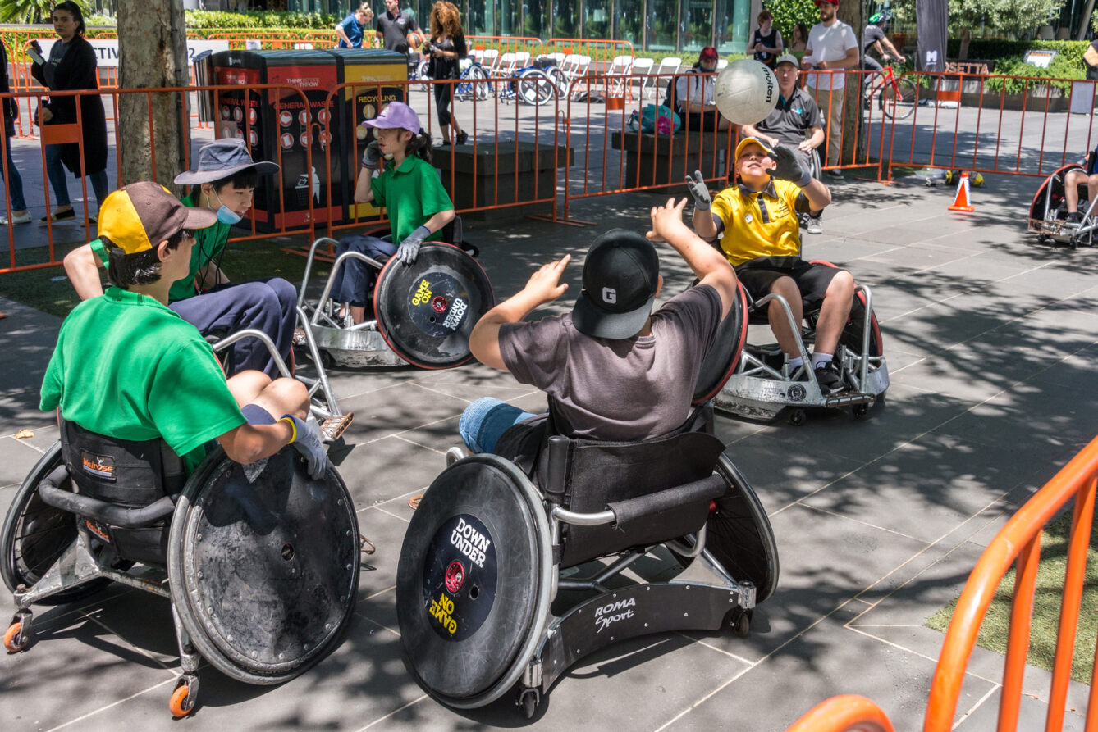

There will be wheelchair rugby games for you to watch, and you can
have a go at playing wheelchair basketball or wheelchair AFL.
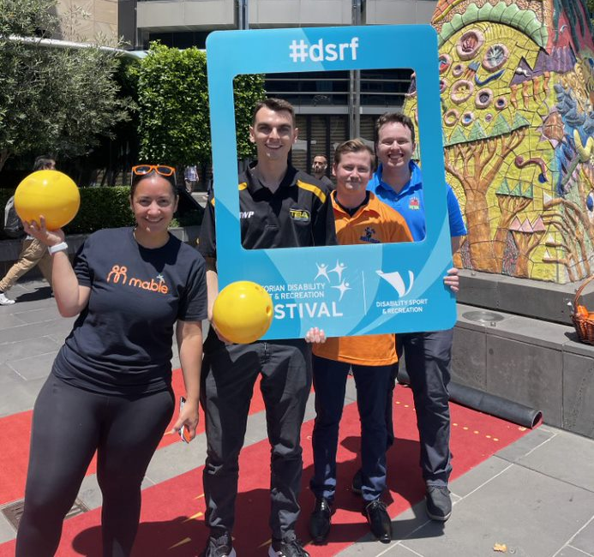

You can have your photo taken with the blue Festival frame if you like.
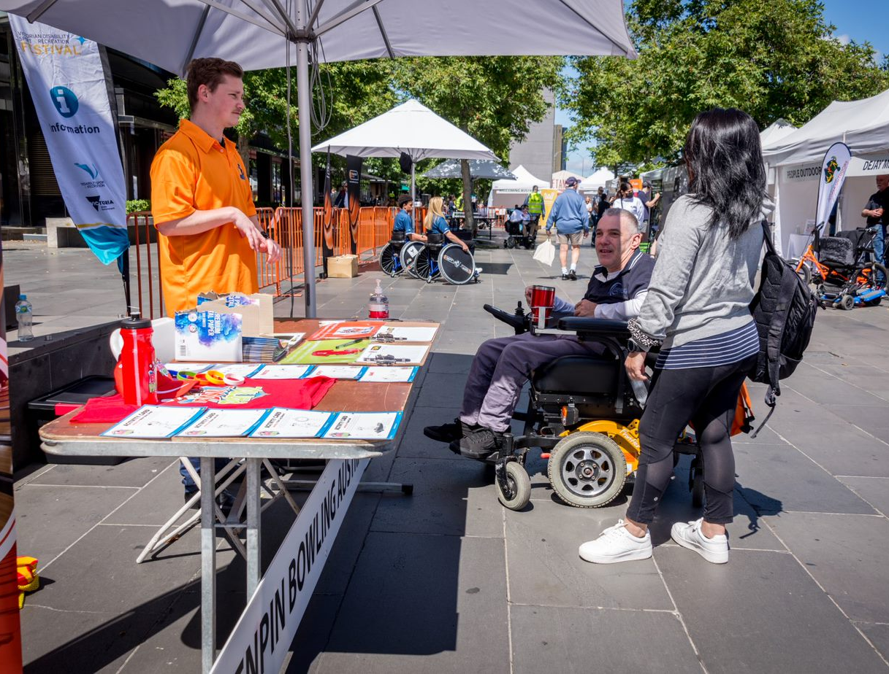

If you get lost or have any questions during the event,
our staff at the information desk can help you.
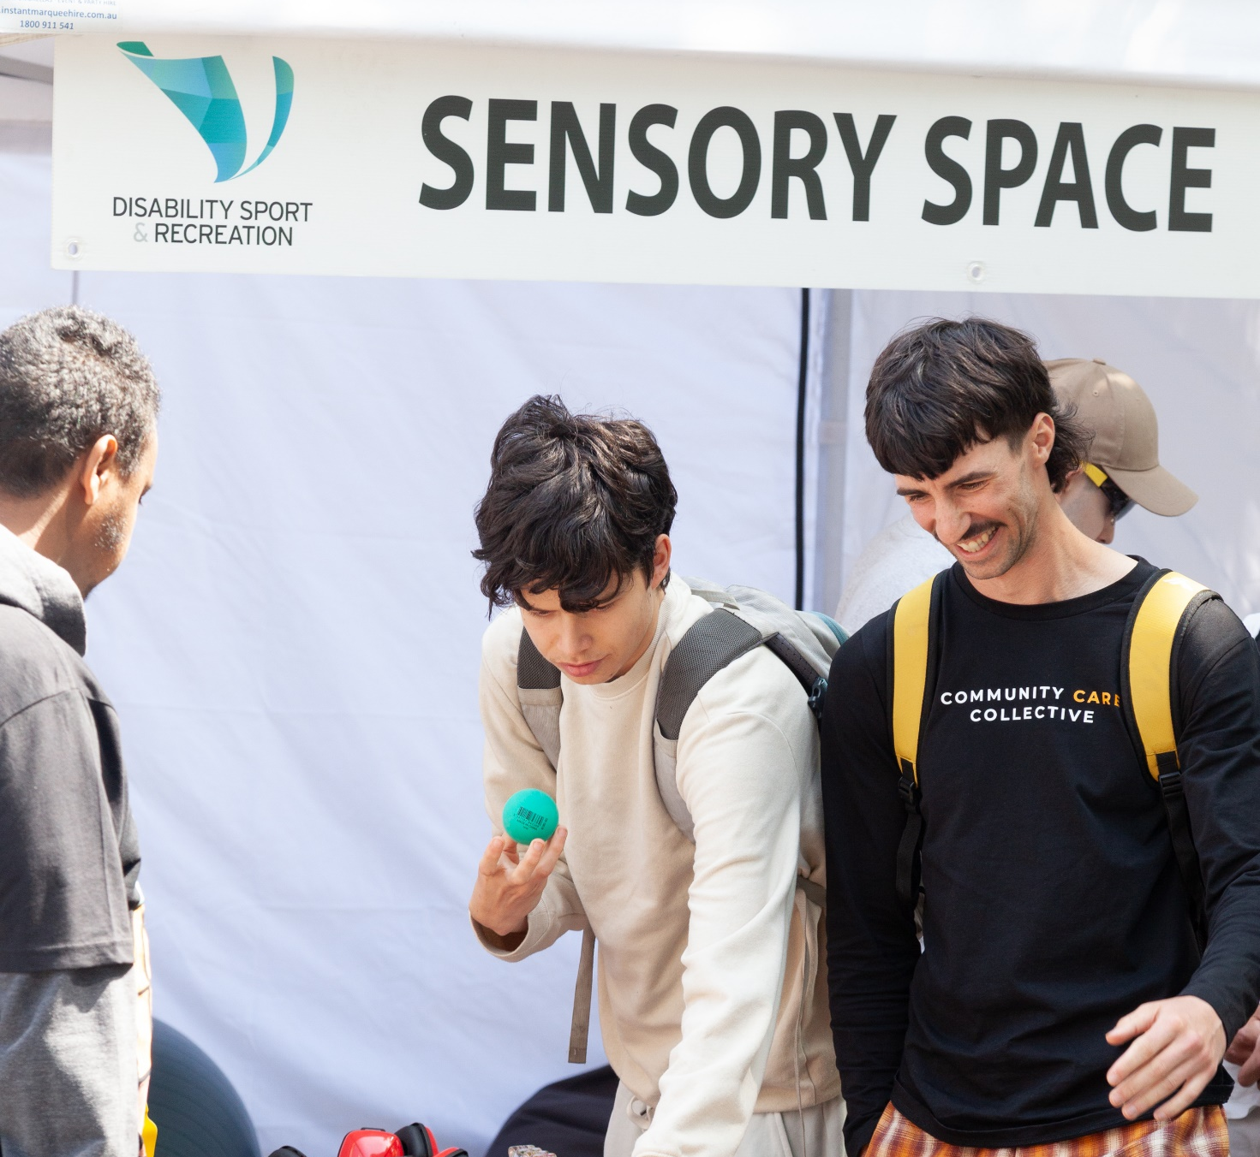

There will be a First Aid tent and sensory space if you would
like to sit down and take a break or have some quiet time.
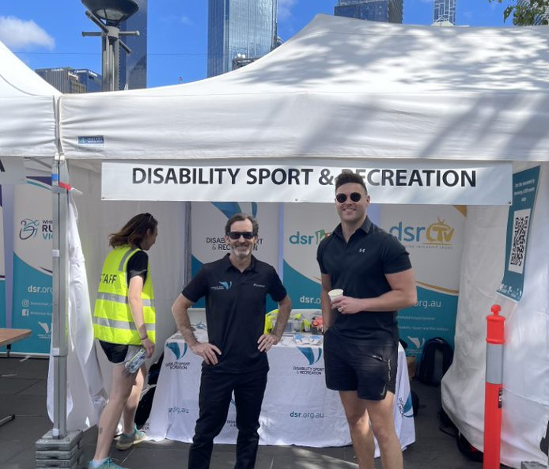

Our friendly staff at the Disability Sport & Recreation tent can direct
you to the water fountains, bathrooms and water bowls for service animals.

